# CS 255 System Design Document Template

This template lays out all the different sections that you need to complete for Project Two. Each section has guidance to prompt your thinking. You will need to continually reference the interview transcript as you work to make sure that you are addressing your client’s needs. There is no required length for the final document. Instead the goal is to complete each section based on what your client’s needs are. Remove this note when you are finished, and replace all bracketed text with the relevant information.

## UML Diagrams

### UML Use Case Diagram

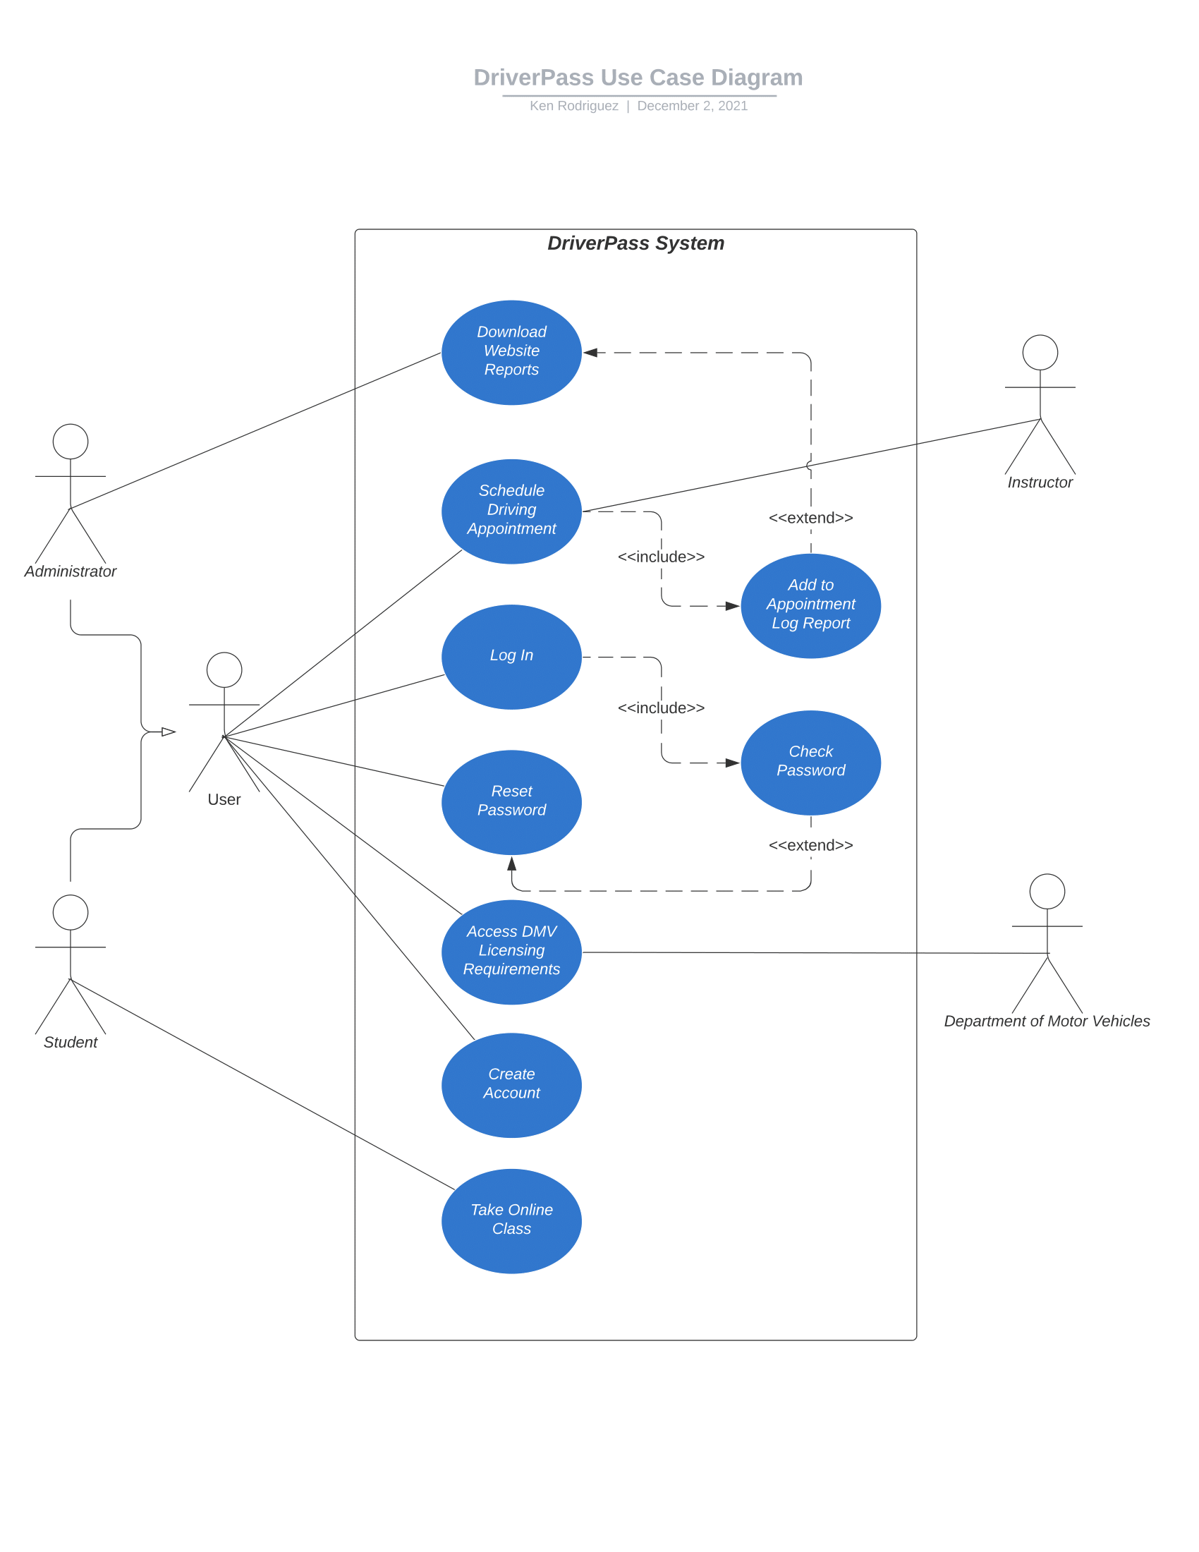

### UML Activity Diagrams

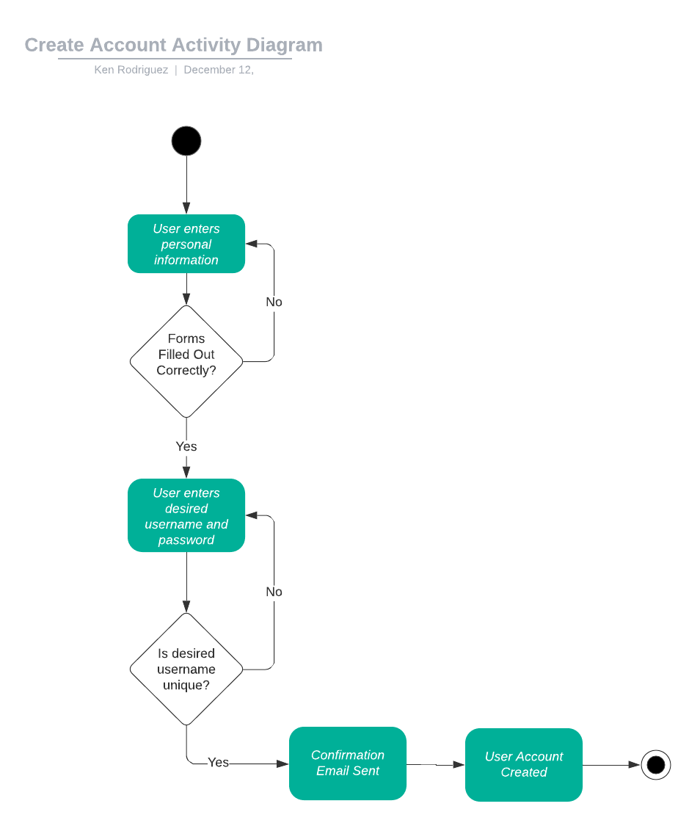

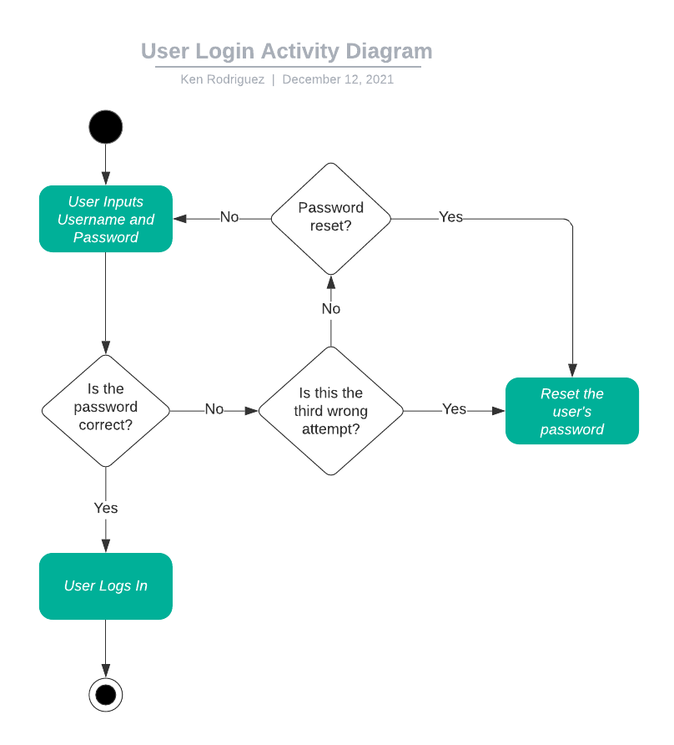

### UML Sequence Diagram

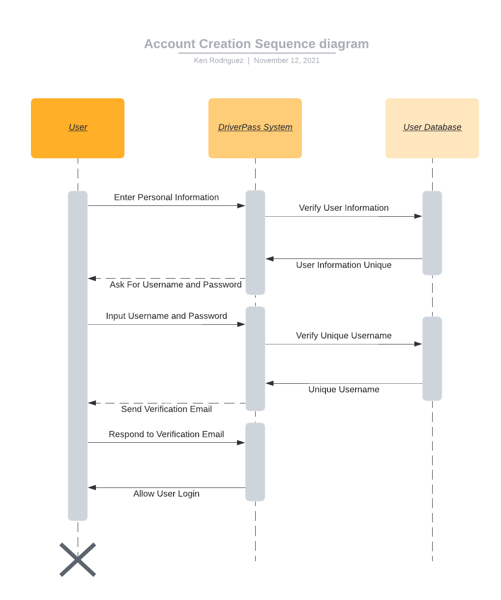

### UML Class Diagram

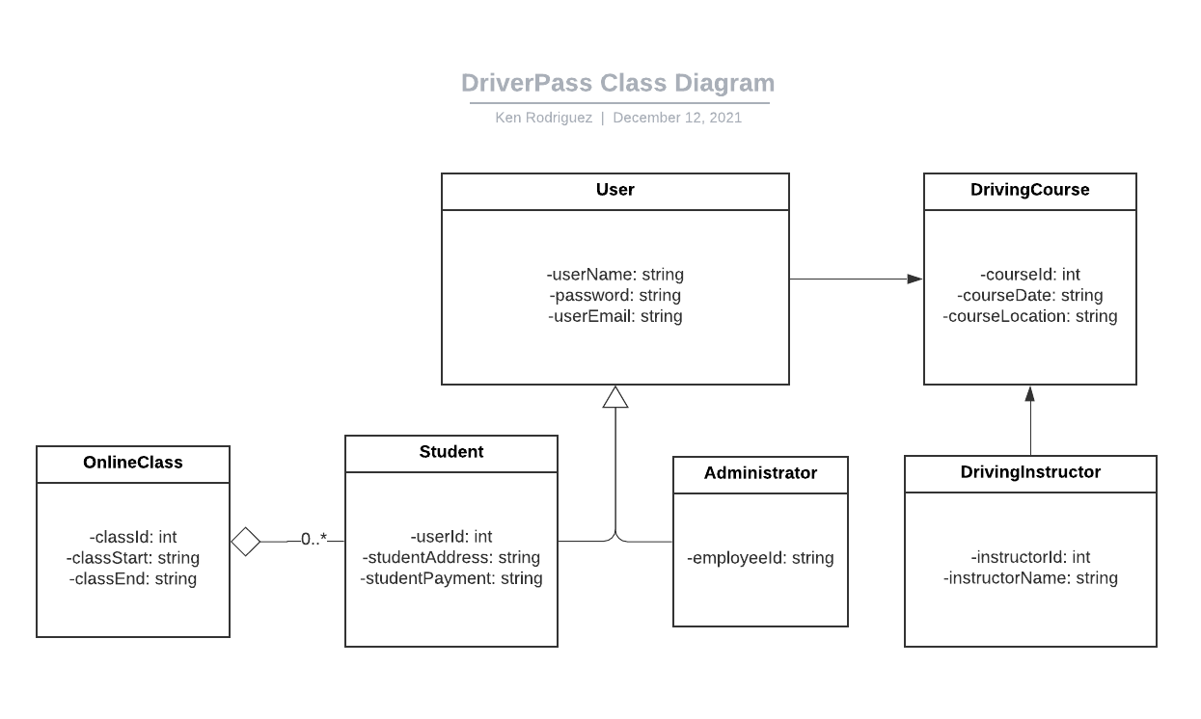

## Technical Requirements

Given that the client has requested that DriverPass run on cloud architecture, an internet connection is required for users to successfully interface with the system. An internet connection will further supplement the system by enabling a constant connection to DMV systems to ensure that the information provided by the courses offered is accurate to the minute. The system will also require personal computers and/or mobile devices for testing and further interfacing with the system. Finally, there should be dedicated server space for databases containing user information, a record of driving courses, and the online courses offered by DriverPass.